**OOP Kelompok 3**

1. Aplikasi pencari dokter

Berikut adalah fitur-fitur yang perlu dibuat:

a. Manajemen data dokter (menambah, edit dan hapus data dokter)

Pengguna dapat menambahkan, memperbarui ataupun menghapus data dokter. Khusus fitur ini perlu dibuat hak akses sehingga pasien tidak bisa mengakses fitur ini.

b. Pencarian dan jadwal dokter

Pengguna dapat mencari dokter berdasarkan hari/spesialis/nama

c. Membuat janji

Pengguna dapat membuat janji temu konsultasi dokter. Selain itu pengguna juga akan diberitahu hasil diagnosa beserta resep obat.

**GUI**

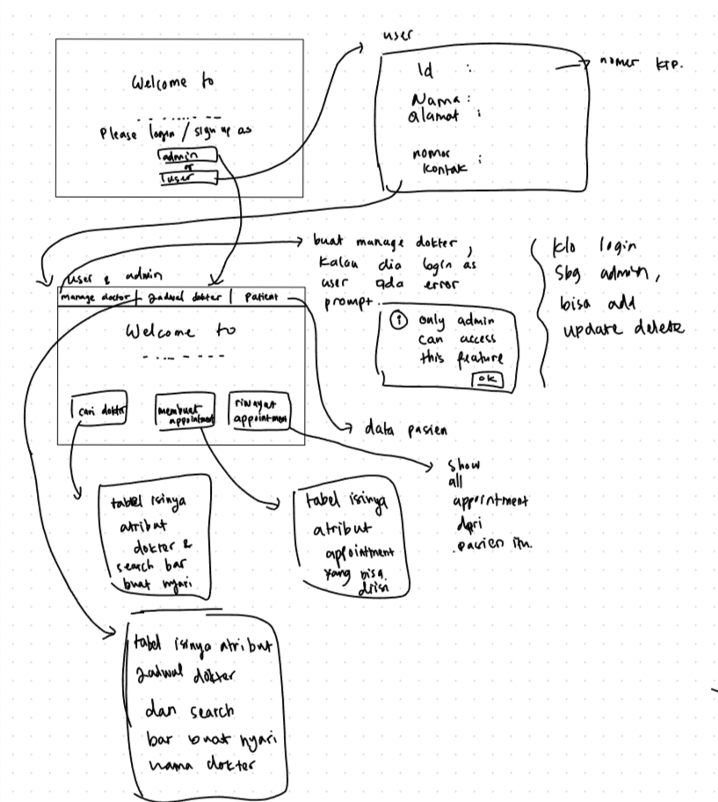

**DATABASE:**

> Dokter

ID Dokter (Primary Key)

Nama Dokter

Spesialisasi

Jadwal Praktik

Nomor Kontak

Alamat Praktik

Informasi lain terkait dokter

> Pasien

ID Pasien (Primary Key)

Nama Pasien

Alamat

Nomor Kontak

Informasi lain terkait pasien

> appointment

ID appointment(Primary Key)

ID Pasien (Foreign Key ke entitas Pasien)

ID Dokter (Foreign Key ke entitas Dokter)

Tanggal dan Waktu Janji

Status Janji (Misal: Terjadwal, Selesai, Dibatalkan)

Hasil Diagnosa

Resep Obat

> Jadwal Praktik Dokter

ID Jadwal (Primary Key)

ID Dokter (Foreign Key ke entitas Dokter)

Hari Praktik

Jam Mulai Praktik

Jam Selesai Praktik

**PROGRESS**

**Code - Commit 1:**

New Feature:

- Add JavaFX Library

- Add BuildPath for JavaFX

- Add Class for Doctor Hunter:

1. Person (Parent Class)

2. User Extends Person

3. Admin Extends Person

4. Doctor Extends Person

5. Patient Extends Person

6. Schedule

7. Appointment

**Code - Commit 2:**

New Feature:

1. Revamped Class User and Admin
2. Add simple GUI for User Experience
3. Add Landing page GUI
4. Add Sign up / Login GUI
5. Add Home Page GUI

**Code - Commit 3:**

New Features:

1. Added Java Scene Builder Library for Java FX
2. Builder Path Scene Builder
3. Revamped All Class to match new Database
4. Revamped GUI using Scene Builder
5. Added Scene for all button and necessary page
6. All UX GUI done (Change Scene)
7. Added connect class for connecting JDBC MySQL
8. Ton of Controller class
9. Ton of fxml class

**Code - Commit 4:**

New Feature:

1. Input Validation for Admin - User type in Manage Doctor (can only be accessed by admin)
2. Input validation for Sign Up
3. Add table for all scene inside Main page
4. Add Search box for all scene inside Main page

**Code - Commit 5:**

New Feature:

1. Connects to database doc_hunter.
2. Can add data admin and user to database from sign up.
3. Upgrade UI for GUI
4. Finalizing data class inside java.

**Code - Commit 6 (FINALIZED):**

New Feature:

1. Search box is available
2. Text field is available for all data
3. Add, Update, Delete Doctor (No. 1)
4. Find Schedule (No. 2)
5. Make appointment (No. 3)
6. GUI completed
7. Back end completed (database)
8. Logic of code completed (java)